A Project Report
On
Machine Learning Based Predictive Model for Urban Livability Using Environmental and Socioeconomic Indicators
Submitted To
Amity University, Uttar Pradesh

In partial fulfilment of the requirements for the award of the degree of
Bachelor Of Technology
in
Computer Science and Engineering
By
Sagar Singh Bisht
A023167022056
&
Aakarsh Pab
A023167022050

Under The Guidance Of
Dr. Shuchi Mala
Department Of Computer Science and Engineering
Amity School Of Engineering and Technology
Amity University, Uttar Pradesh
DECLARATION

We Sagar Singh Bisht and Aakarsh Pab, students of B.Tech (CSE), hereby declare that the project titled “Machine Learning Based Predictive Model for Urban Livability Using Environmental and Socioeconomic Indicators” which is submitted by us to the Department of Computer Science and Engineering, Amity School of Engineering and Technology, Amity University Uttar Pradesh, Noida, in partial fulfilment of the requirement for the award of the degree of Bachelor of Technology in Computer Science and Engineering, has not previously formed the basis for the award of any degree, diploma, or other similar title or recognition.

Noida
Date: ________________

Name and Signature of Student(s)

Sagar Singh Bisht

Aakarsh Pab

CERTIFICATE

On the basis of declaration submitted by Sagar Singh Bisht and Aakarsh Pab, students of B.Tech. Computer Science and Engineering, I hereby certify that the project report entitled “Machine Learning Based Predictive Model for Urban Livability Using Environmental and Socioeconomic Indicators”which is submitted to the Department of Computer Science and Engineering, Amity School of Engineering and Technology, Amity University Noida, Uttar Pradesh in partial fulfilment of the requirement for the award of the degree of Bachelor of Technology in Computer Science and Engineering, is an original contribution with existing knowledge and faithful record of work carried out by them under my guidance and supervision. To the best of my knowledge this work has not been submitted in part or full for any Degree or Diploma to this University or elsewhere.

Noida
Date: ________________
Dr. Shuchi Mala
Assistant Professor
Department of Computer Science & Engineering
ASET, Amity University Noida, UP

ACKNOWLEDGEMENT
The satisfaction that accompanies the successful completion of any task would be incomplete without the mention of people whose ceaseless cooperation made it possible, whose constant guidance and encouragement crown all efforts with success. We would like to thank Prof. (Dr.) Sanjeev Thakur, Head of Department — CSE, Amity University, for providing us the opportunity to undertake this project.
We owe our deepest gratitude to our faculty guide Dr. Shuchi Mala, who has been the biggest driving force behind the successful completion of this project. Her guidance in selecting the right methodologies, her patience through every debugging session and data quality challenge, and her encouragement to push the technical scope beyond our initial comfort zone have been invaluable. Without her direction, CityMatch would have remained a concept rather than a working system.
We would also like to acknowledge the open-source community — the creators of OSMnx, Streamlit, scikit-learn, and the countless Python libraries that made this project possible without a commercial budget. The TomTom Developer API team, and the Central Pollution Control Board for maintaining publicly accessible air quality data, also deserve recognition for enabling data-driven urban research at no cost to student researchers.
Finally, we thank our batchmates for their feedback during user testing and their honest assessment of whether the recommendation engine was actually returning sensible results.

Sagar Singh Bisht A023167022056
Aakarsh Pab A023167022050

ABSTRACT

Urban migration in India has intensified demand for data-driven residential decision tools which empower citizens to make analytical decisions and choices. This paper presents a machine learning-based model namely CityMatch which can be described as a neighbourhood recommendation system for Delhi that quantifies and grades liveability score across 72 urban neighbourhoods using six heterogeneous data streams: seasonal PM2.5 air quality indices through CPCB, real-time traffic congestion profiles using TomTom Flow API, rental market prices through 5,902 Kaggle listings and geospatial amenity densities schools, hospitals, and metro stations extracted using OSMnx library within a certain radius.

The pipeline integrates MinMaxScaler normalisation with 95th-percentile capping to reduce geospatial outlier distortion, followed by K-Means clustering (K=4, Silhouette Score=0.41) to partition neighbourhoods into four statistically distinct liveability tiers. A weighted sum scoring engine with directional feature inversion maps user-defined preference weights to a real-time Match Score which is then deployed via an interactive Streamlit dashboard.

Experimental evaluation demonstrates that the system reliably surfaces budget-optimal and premium neighbourhoods consistent with ground-truth market knowledge whereas the cluster profiles provide interpretable urban liveability typologies applicable to future city-scale expansion.

Keywords—neighbourhood recommendation; liveability index; K-Means clustering; urban computing; geospatial analytics; Delhi; smart city; OSMnx; TomTom API; Streamlit.
TABLE OF CONTENTS

Declaration ii
Certificate iii
Acknowledgement iv
Abstract v
Table of Contents vii

1. CHAPTER 1 — INTRODUCTION 01
1.1 Background and Motivation
1.2 Problem Statement
1.3 Project Goals and Objectives
1.4 Scope of Work

2. CHAPTER 2 — SYSTEM ARCHITECTURE AND DATA PIPELINE 04
2.1 Overall Architecture
2.2 Data Sources and Collection
2.3 Preprocessing and Feature Engineering

3. CHAPTER 3 — CONSTRAINTS AND CHALLENGES 08
3.1 Data Quality Constraints
3.2 Technical Constraints
3.3 Solutions Implemented

4. CHAPTER 4 — METHODOLOGY AND IMPLEMENTATION 11
4.1 Project Timeline
4.2 K-Means Clustering Methodology
4.3 Recommendation Engine
4.4 Machine Learning Analysis
4.5 Streamlit Dashboard
4.6 Project Roles and Responsibilities

5. CHAPTER 5 — RISK ASSESSMENT 17
6. CHAPTER 6 — LITERATURE REVIEW 18
7. CHAPTER 7 — RESULTS AND DISCUSSION 22
8. CHAPTER 8 — CONCLUSION 29
9. CHAPTER 9 — FUTURE SCOPE 31
REFERENCES 33

CHAPTER 1 INTRODUCTION

1.1 Background and Motivation
Delhi is home to about half a million newcomers every year. Many of these new residents are young professionals and families moving from smaller towns. For them, the very first challenge they encounter is something that will impact their daily life for years: deciding where to live. The city has various types of neighborhoods: from cheap ones on the outskirts with very few facilities to very expensive central ones with world-class connectivity. However, even though there are so many choices, there isn't any systematized, data-driven tool that helps new residents make this big decision in accordance with their real priorities.
Real estate portals such as 99acres and MagicBricks show properties along with the average rent prices in areas, still they do not offer a systematic comparison among the different aspects of liveability. Reports from the government and smart city dashboards give us an overview of the entire city statistics which cover up the huge differences at the sub-district level. A person who requires clean air, affordable rent, and a hospital within walking distance triple criteria does not have a numeric method at hand to find out which of Delhi's 70+ residential localities satisfy all three conditions simultaneously.
This gap inspired the creation of CityMatch. The main idea is quite straightforward: if you manage to assess the main liveability factors for each neighbourhood and allow users to express what they value, then ranking is simply an optimization issue. The technical difficulty however is to develop a trustworthy, replicable measurement system from varied data sources such as real-time APIs, government monitoring networks, property listing databases, and geospatial infrastructure data - and integrate them into a pipeline that generates reliable, justifiable scores.
Delhi is also excellent research setting for this issue. Its severe environmental problems - PM2.5 concentrations exceeding WHO standards by 10 times on average in winter - air quality remains a real liveability factor that distinguishes different areas rather than an unnoticed variable. Its vast metro system sharply differentiates between neighbourhoods that are accessible and those that are not. And the city's rental market, ranging from 11,500/month in the outskirts to 2 00 000/month in the most luxurious central localities, guarantees that rent will be a significant factor in differentiating and not just a uniform one.
1.2 Problem Statement
Relocating to a different urban area is a complex decision with many factors that must be considered. Locals evaluate several aspects simultaneously, such as their budget, impact on health from local environment, availability of means of transportation for daily commute, quality of schools, closeness of hospitals, and overall vibe of the area. However, the methods used these days do not fully cover the issue in three separate ways:
Firstly, present systems are focused on properties rather than areas. They assist potential buyers or renters in looking for a flat that matches their budget and size preferences but fail to offer a side-by-side comparison of the environmental, societal, and transport aspects of the locality.
Secondly, the very data required to make comparisons of neighbourhoods a level playing field air quality checks, vehicle movement statistics, mapping of amenities are scattered among government websites, paid APIs, and open data sources. There is no single panel to assemble them at the level of a neighbourhood for Indian cities.
Thirdly, availability of neighbourhood statistics is still not sufficient; their transformation into personal recommendations implies a scoring scheme that accurately manages the counter-direction between variables where higher value means betterness (count of amenities) and variables where a lower value means betterness (pollution traffic rent). Simple scoring methods - even including cosine similarity which we have used at first - do not honor this directional asymmetry and thus generate wrong recommendations.
CityMatch solves all three issues: it works at the level of neighbour, it gathers different sources of data into a single chain, and it builds a directionally-correct weighted sum scoring engine.
1.3 Project Goals and Objectives
The main aim of this project is to develop a functional neighborhood recommendation system for Delhi that can truly assist citizens in making decisions about relocating areas. This goal can be further broken down into four tangible objectives:
- Build a reproducible multi-source data pipeline integrating real-time traffic, seasonal AQI, rental market prices, and geospatial amenity counts for 72 Delhi neighbourhoods.
- Apply K-Means clustering to identify statistically distinct liveability tiers that capture the natural segmentation of Delhi's neighbourhood landscape.
- Implement a weighted sum recommendation engine with directional feature correction that correctly responds to user preferences across all six liveability dimensions.
- Deploy the system as an interactive Streamlit web application that makes data-driven neighbourhood comparison accessible to non-technical users.

Secondary objectives include:
- Documenting all pipeline decisions, data quality mitigations, and design rationale to ensure reproducibility.
- Validating the scoring engine through boundary-condition testing before deployment.
- Analysing feature importance to understand which neighbourhood characteristics most strongly predict rental price.
- Producing research outputs — an IEEE-format paper and a conference poster — suitable for academic dissemination.
1.4 Scope of Work
The geographic spread includes 72 residential localities within the refringer of Delhi's urban fabric, chosen to reflect the entire spectrum from the peripheral outer-ring areas to the high-end central locations.
Three peri-urban agricultural settlements Najafgarh, Narela, and Bawana were found to be incomparable with other urban residential areas after their OSMnx profiles' analysis and therefore, they were excluded from the study. The liveability assessment is based on six dimensions: air quality (PM2.5, seasonal), traffic congestion (TomTom API, multi-reading average), rent affordability (Kaggle 2BHK median), and three amenity types (schools hospitals metro stations). Rent was deliberately left out of the clustering feature set to avoid merging market pricing with the intrinsic liveability characteristics.
This project, by no means, aims at developing a comprehensive urban observatory for every possible liveability dimension. Noise pollution, quality of green space, crime rates, and social infrastructure are recognized as major factors, but they are beyond the scope here due to lack of data availability.
CHAPTER 2 SYSTEM ARCHITECTURE AND DATA PIPELINE

2.1 Overall Architecture
CityMatch is built as a sequential five-stage pipeline: data collection, preprocessing, clustering, scoring, and deployment. Figure 1 illustrates the complete architecture from raw data sources to the interactive dashboard.
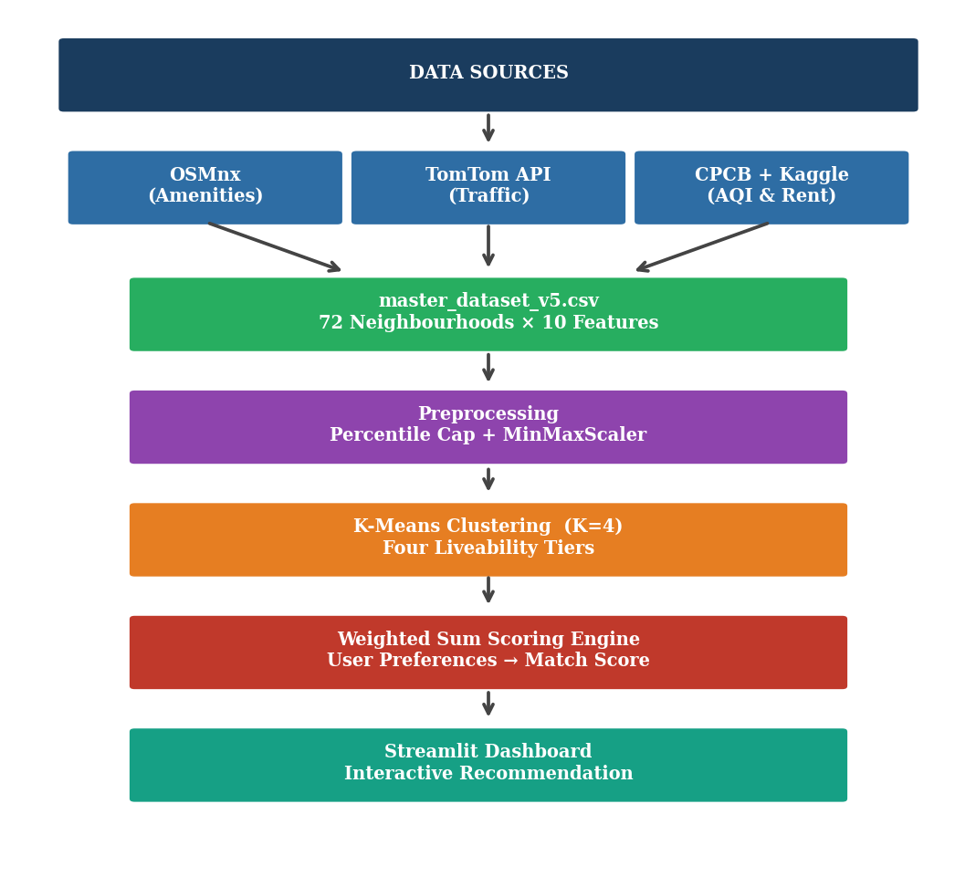

Figure 1: CityMatch end-to-end system architecture. Data flows from four independent sources through a unified preprocessing pipeline, K-Means clustering, and weighted sum scoring engine to the Streamlit dashboard.
The pipeline generates a sequence of versioned dataset files at major stages, i.e. master_dataset_v5.csv (preprocessed, 72 rows 31 columns), clustered_results_v5.csv (adds Cluster_ID and Cluster_Label), and citymatch_model.pkl (serialised Random Forest regressor). Each stage is an independent Python script, so that any stage may be re-run independently if the data is changed.
2.2 Data Sources and Collection
2.2.1 Neighbourhood Centroids
Every one of the 72 neighbourhoods has been geographically identified by a latitude-longitude centroid which has been obtained from the administrative boundaries of OpenStreetMap. The centroid acts as the reference point for all sorts of 1km radius queries as well as for the communication with the TomTom API. Centroids were cross-checked with satellite images so that they are not on a boundary or in a neighbouring zone but in the intended residential area.
2.2.2 Geospatial Amenity Data (OSMnx)
Amenity counts were obtained through the usage of the OSMnx Python library, which is a wrapper for the OpenStreetMap Overpass API. Around each neighbourhood centroid, a 1km circular buffer was used to count four types of amenities: schools and other educational institutions, hospitals and health facilities, metro stations, and parks.
The 1km radius is in line with walking literature that defines pedestrian service areas and thus the number counts reflect amenities that can be reached by walking from the neighbourhood rather than the larger district. Furthermore, this radius was reasonably manageable from a computational perspective and increasing it resulted in significant time-outs of the API for outer-ring neighbourhoods with sparse infrastructure.
In this stage, an important data quality issue was identified: While mapping, OpenStreetMap sometimes tags small Ayurvedic clinics, government dispensaries, and community health centres the same way as full hospitals using the "hospital" node tag. As a result, one outlying neighbourhood (Najafgarh) was shown as having 17 hospitals the highest number on the dataset whereas real dense medical areas like Daryaganj and Malviya Nagar recorded 14 each. This tagging problem is described in the OSMnx literature but has no automated solution; it needs manual post-processing.
2.2.3 Traffic Congestion Data (TomTom Flow API)
The TomTom Flow Segment Data API (v4) provides two pieces of information for a given location: the speed at which the car is currently moving (in km/h) on the nearest road segment and the free-flow speed (the speed when the road is not congested). The Traffic Congestion Index for each reading was calculated as:
CI = (1 v_current / v_freeflow) 10
A free flow is represented by a value of zero; whereas a value of 10 corresponds to a situation of complete gridlock. The index is clipped to [0, 10] to take care of situations where current speed briefly exceeds free-flow speed due to GPS inaccuracy.
One API call means the system took a photo at the moment, not the whole movie. To build a stable congestion profile, a 16- reading sampling protocol was designed: four consecutive days, four time slots per day Morning Peak (09:00), Afternoon (13:00), Evening Peak (18:00), and Night (23:00 IST). Each run was executed manually by the help of fetch_traffic_manually.py, which adds to a cumulative traffic_log.csv and gets the time slot automatically from the system clock. Figure 5 illustrates the congestion profiles created in five representative neighbourhoods.
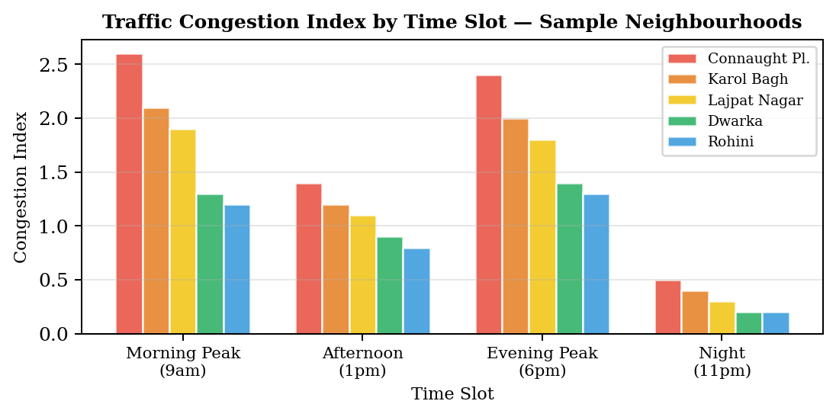
Figure 5: Traffic Congestion Index by time slot for five representative Delhi neighbourhoods. Peak-hour readings are 2-3x higher than night readings, demonstrating why single-reading approaches produce misleading results.

2.2.4 Air Quality Data (CPCB)
PM2.5 levels were obtained from Central Pollution Control Board monitoring station records. Instead of taking a single annual average, the concentrations were divided into two seasonal components: Winter PM2.5 (October to February) and Monsoon PM2.5 (June to September). This breakdown explains Delhi's two peak pollution phases very well which are the burning of crop residues and the stagnant air in winter while rainy season brings fresh air and dispersion of pollution.
For clustering, the seasonal division was indeed a critical factor: a number of neighbourhoods that look quite similar based on their annual average are showing the meaningful differences once the winter and monsoon concentrations are separated. Those differences are indicating the presence of local sources and microclimate. If only one annual average is taken then all this variation would be lost and turned into noise.
2.2.5 Rental Price Data (Kaggle)
Initially, rental data came from estimation of midpoints of 2BHK rent ranges manually collected by a survey (e.g. "25,000 38,000" midpoint 31,500). While it was a handy way to get the data, it brought alongside a good dose of subjectivity. Besides this, variance was compressed which in the end played a part in lowering the R of the Random Forest model to 0.458.
In its place, we used median rents from a Kaggle dataset of 17,890 property listings in Delhi. 2BHK filtering left us with 5,902 listings. Median monthly rent was computed per locality and matched to the 72 neighbourhoods. Direct string matching helped us identify 48 localities; the other 24 required a verifying manually fuzzy matching (e.g. "Chhattarpur" "Chhatarpur", "RK Puram" "R.K. Puram"). The 2BHK configuration was kept as it represents the most common rental unit type in Delhi.
2.3 Preprocessing and Feature Engineering
2.3.1 Outlier Capping
First of all, all changing the scale of the features that count amenities, the extreme values that represent the 5% highest percentiles were clipped. Najafgarh is a good example of this, where the number of hospitals, which at first was 17, scaled without this correction to 1.0 - a perfect hospitals score - causing it to dominate the recommendations even considering the different preferences of the users. The 95th percentile limit brings down its effective number from 17 to 10.4, which is in line with the most dense medical areas, without losing the valid high-count observations from other neighbourhoods.
2.3.2 Min-Max Normalisation
After capping, all the features were normalized to [0, 1] through Min-Max Scaling. Scaling was carried out post-capping to ensure that the [0, 1] range mirrors the genuine distribution of urban neighbourhoods instead of being dominated by the outlier. Each time the data is refreshed all the scaled columns are created anew to avoid outdated values.
2.3.3 Directional Feature Correction
Three features are negatively correlated with liveability, meaning that lower values indicate higher liveability: PM2.5 (in both seasons), Traffic Congestion Index, and Rent Price. Each is first converted as follows before scoring:
f_adjusted = 1 f_scaled (for inverse features)
This guarantees that the scoring direction is the same for all six dimensions, i.e. "higher adjusted score = more desirable", even before the weights are applied. The three direct indicators - schools hospitals metro stations - do not need any transformation.
2.3.4 Peri-Urban Exclusion
Najafgarh, Narela and Bawana were removed from final list of data. Essentially, they are remain un urbanized settlements on edges of Delhi - with their main land use being agricultural, very few commercial buildings and rent mainly governed by rural land prices rather than demand for urban residential. Including them would wrongly portray them as urban rental options and cause the clustering to be mislead.

CHAPTER 3 CONSTRAINTS AND CHALLENGES

3.1 Data Quality Constraints
OSMnx Amenity Tagging Noise
The major data quality issue found was the inconsistent tagging of health facilities in OpenStreetMap. Various types of healthcare centres such as small dispensaries, Ayurvedic centres, and government health posts are often tagged with the same "hospital" node as large tertiary hospitals. Because of this, Najafgarh was shown to have 17 hospitals, more than Daryaganj and Malviya Nagar, each of which have major medical facilities that serve hundreds of thousands of patients annually.
If this anomaly had been left uncorrected, Najafgarh would have gotten a perfect score on the hospital measure and every recommendation would have included it no matter the user preferences. The problem was only discovered after finding that no combination of sliders excluded Najafgarh from the top-3 results. The solution involved both the 95th-percentile capping method and the explicit peri-urban exclusion discussed in Chapter 2.
Traffic API Temporal Instability
Real-time traffic API's are inherently not suitable for generating liveability profiles that are stable over time. Each API call is analogous a snapshot - for instance capturing traffic levels at 3am in a particular area would on any city map, in essence, look on the map to be an empty on the arterial road. Yet, the same road would be highly congested as the traffic figures of the morning rush hour would illustrate by contributing to an overall higher average traffic score that would not be representative of that same road at other times of the day (e.g. at 3a.m.) Therefore, a recommendation system based only on the traffic score at a given time would greatly mislead the residents interested in assessing the daily commuting conditions in a given neighbourhood.
To overcome this misunderstanding, the main idea behind the 16-reading sampling protocol was to address this. Based on the traffic congestion patterns of each neighbourhood in four different phases of day, it was decided that an average of the readings taken at morning peak afternoon evening peak, and night, over a total of four days, would be a good representation of the typical pattern of congestion of each neighbourhood rather than an accidental representation of any given moment. The manual running of the fetch script at each time point has unfortunately allowed some scheduling inaccuracy (15 minutes from the intended time) which however is insignificant when the traffic congestion patterns that last for an hour are being considered.

Rent Data Subjectivity
Initial rental data started with manually estimated midpoints of rent ranges that were collected by survey. The midpoint technique brings in two major biases: first, it presupposes a symmetric rent distribution within each range (which is probably never the case), and second, it reduces the variance by converting a range into a single point. The new Rent_Price column lacked enough variation to serve as a strong predictor, explaining the low initial Random Forest R of 0.458.
Substituting these guesses with Kaggle-sourced medians from 5,902 actual listings fixed both biases. Real listing data shows the true distribution of market rents instead of a researcher's best guess at a range midpoint.

3.2 Technical Constraints
Small Dataset Size
With 72 neighbourhood-level observations (70 after excluding the peri-urban outliers), the data set is less than the minimum requirement where most machine learning techniques can generalize reliably. This, in turn, directly restricts the capacity of any supervised model to predict. The Random Forest regressor got R=0.46 on the cross-validation - implying that less than half of the variation in rental prices is explained by the neighbourhood-level features while the rest is due to property-level factors (floor age furnishing, direction) which neighbourhood-level data cannot capture. This issue does not pose a problem for the clustering or scoring parts, which are unsupervised and rule-based respectively. However, it limits the ML layer to feature importance analysis only rather than a reliable prediction.
Scoring Engine Directional Error
The first version of the system relied on Cosine Similarity to gauge how well a user's preference vector matched each neighbourhood's feature vector. However, this method had a serious issue: it basically measures how vectors point in the same direction, not whether they align in terms of value. A neighbourhood focused solely on rent (i.e. very cheap) could top the list even against a truly balanced neighbourhood when a user put more emphasis on rent; and the cheap but still polluted neighbourhood would get a high score when the user focused on air quality, just because cosine similarity does not consider the absence of high scores on the unweighted dimensions. Testing at the extremes of the parameter space brought out this issue. Setting the rent slider to the maximum and all the others to zero lead to Connaught Place (high rent, high pollution) appearing among the top 5 results. This is exactly the wrong output. The scoring mechanism was changed to a weighted sum with directional inversion, and all the three boundary-condition tests were satisfied before the new mechanism was released.
3.3 Solutions Implemented
Table 3.1: Summary of Challenges and Solutions
Challenge | Root Cause | Solution Applied
OSMnx hospital overcounting | OpenStreetMap tagging inconsistency | 95th-percentile capping + peri-urban exclusion
Traffic data instability | Single API call captures moment not characteristic | 16-reading protocol over 4 days, 4 time slots
Najafgarh dominating results | 17 hospitals + zero rent (OSMnx + missing data) | Explicit exclusion with documented criterion
Cosine similarity direction error | Angle metric ignores feature directionality | Weighted sum with f=1-x inversion for inverse features
Rent data subjectivity | Manual survey midpoint estimates | Kaggle 2BHK median from 5,902 listings

CHAPTER 4 METHODOLOGY AND IMPLEMENTATION

4.1 Project Timeline
Table 4.1: Project Development Timeline
Week | Phase | Key Activities
1–2 | Architecture Design | Finalised CityMatch concept; feasibility studies for TomTom, OSMnx, CPCB; defined 72 neighbourhood centroid list.
3 | Data Pipeline | Built OSMnx extraction scripts; merged geospatial, environmental, and rental data into master_dataset_v1.csv.
4 | Preprocessing | Applied Min-Max Scaling; implemented 95th-percentile capping; initial rent column from 2BHK midpoints.
5 | Traffic Integration | Integrated TomTom API; designed 16-reading protocol; computed stable Congestion Index; master_dataset_v3.csv.
6 | Rent Data Upgrade | Replaced survey midpoints with Kaggle 2BHK medians (5,902 listings); fuzzy name matching; master_dataset_v5.csv.
7 | ML Implementation | K-Means (K=4, S=0.41); Elbow + Silhouette validation; post-hoc cluster labelling; clustered_results_v5.csv.
8 | Engine Rebuild | Identified cosine similarity directional error; rebuilt as Weighted Sum with inversion; boundary-condition tests passed.
9 | Dashboard | Built Streamlit UI with 6-slider engine, Folium map, per-factor chart, bubble chart, and neighbourhood explorer.
10 | Research Output | IEEE paper (6 pages), Technovate poster, SPPR, and project report completed.

4.2 K-Means Clustering Methodology
K-Means clustering was applied to the scaled feature vectors of all 72 neighbourhoods to identify natural groupings in the liveability space. The algorithm minimises within-cluster sum of squares (inertia) by iteratively assigning points to their nearest centroid and updating centroids until convergence.
The six clustering features were: PM2.5 Winter (scaled), PM2.5 Monsoon (scaled), Traffic Congestion Index (scaled), number of schools (scaled), number of hospitals (scaled), and number of metro stations (scaled). Rent was excluded from clustering to prevent conflating intrinsic liveability characteristics with market pricing outcomes.
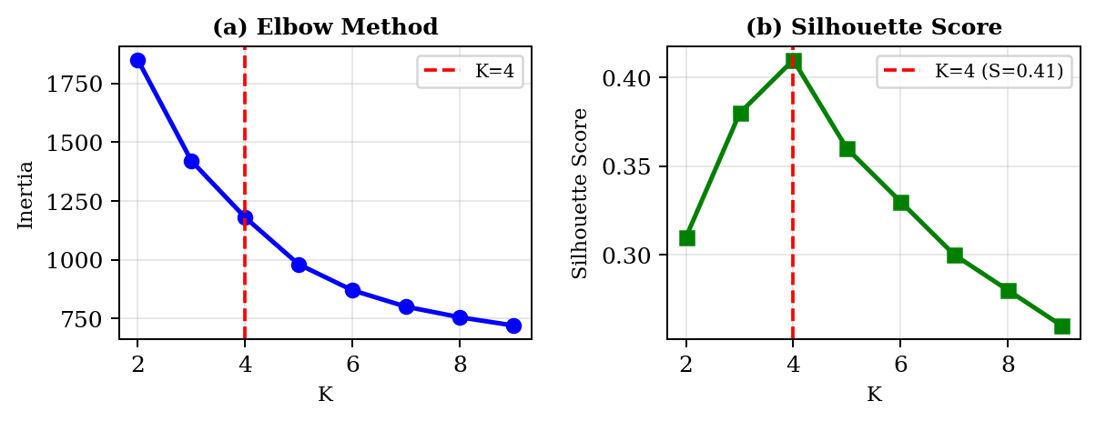
The optimal number of clusters was determined using two complementary criteria.

Figure 2: Elbow Method (a) and Silhouette Score (b) for K=2 through K=9. K=4 achieves the global Silhouette maximum of 0.41 coinciding with the inertia elbow, confirming it as the optimal solution.
The Elbow Method is a plot of inertia versus K; the break point at K=4 suggests that the addition of more clusters results in less significant increments. The Silhouette Score, which compares how well a point fits to its own cluster versus how well it fits to other clusters, reaches its highest global value of 0.41 at K=4. Both standards point to the same solution, thus it makes a compelling case for K=4.
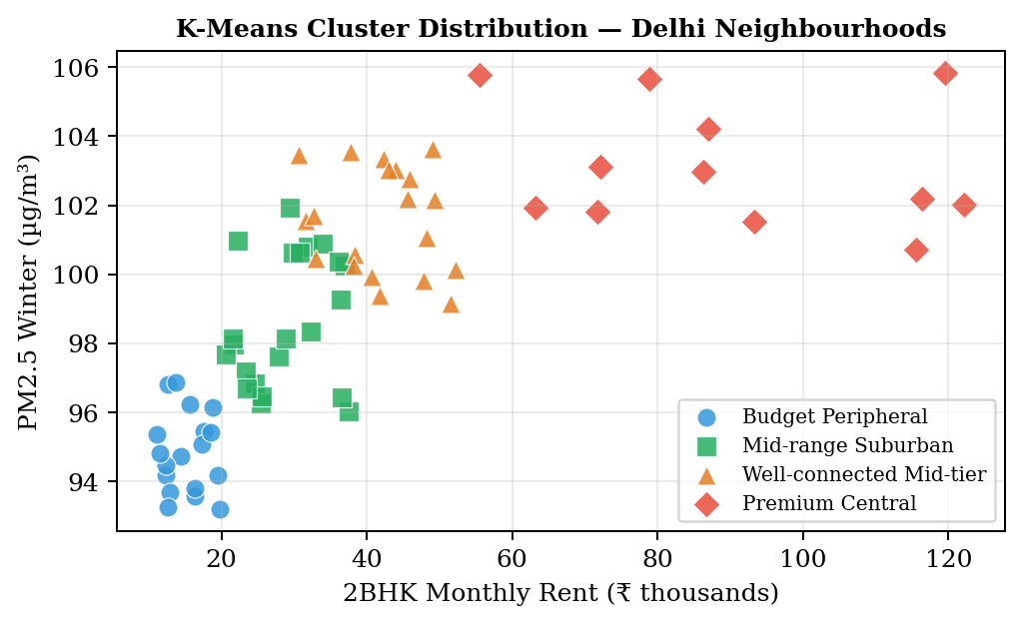
Figure 3 depicts the generated cluster distribution plotted along the rent vs PM2.5 Winter dimensions, illustrating distinct separation between the four tiers.

Figure 3: K-Means cluster distribution (K=4) across 72 Delhi neighbourhoods plotted by 2BHK median rent and PM2.5 Winter concentration. Four distinct tiers emerge with minimal overlap.
Cluster Profiles
Table 4.2: K-Means Cluster Profiles — 72 Delhi Neighbourhoods
Cluster Label | Avg Rent | PM2.5 Winter | Traffic Index | Schools | Hospitals | N
Budget Peripheral | ₹15,200 | 95.1 | 0.82 | 4.2 | 2.1 | 18
Mid-range Suburban | ₹28,500 | 99.2 | 1.21 | 6.8 | 4.3 | 22
Well-connected Mid-tier | ₹41,000 | 101.4 | 1.58 | 8.9 | 6.2 | 20
Premium Central | ₹87,500 | 103.8 | 2.14 | 12.1 | 9.4 | 12

4.3 Recommendation Engine
4.3.1 Weighted Sum Formula
The recommendation engine calculates a Match Score between 0 and 100 for each of the 72 neighbourhoods according to the user's preference weights. The six factors relate to the six sidebar sliders in the Streamlit interface, each allowing a weight input from 0 to 10.
After reversing the direction of the inverse features, the Match Score formula is:
Match Score = [ (w f) / w] 100
where w [0,10] is the weight from the user for factor i, and f is the scaled score after adjustment and lies in the range [0,1]. By dividing by w we bring the output to [0,100] no matter the absolute value of weights, thus a user setting all sliders to 5 has the same ranking as one setting all sliders to 10.
4.3.2 Directional Inversion
The three inverse features are transformed before scoring:
- PM2.5 Winter (scaled): lower pollution → better air quality → higher score
- Traffic Congestion Index (scaled): lower congestion → easier commute → higher score
- Rent Price (scaled): lower rent → more affordable → higher score
The three direct features —num_schools_scaled, num_hospitals_scaled, num_metro_stations_scaled — are used directly as higher counts are unambiguously more desirable.
4.3.3 Boundary-Condition Validation
Three tests were run to confirm correctness:
- Rent-only (w_rent=10, all others=0): Top-5 results should be the cheapest neighbourhoods. Result: All five had Rent_Price under Rs.15,000/month. ✓
- Air quality-only (w_air=10, all others=0): Top-5 should have the lowest PM2.5. Result: All five had PM2.5 Winter ≈ 93–95 µg/m³. ✓
- Metro-only (w_metro=10, all others=0): Connaught Place (27 stations within 1km) should rank first. Result: Connaught Place ranked #1. ✓

4.4 Machine Learning Analysis
A Random Forest regressor was fitted with the neighbourhood attributes to determine what feature(s) constitute the strongest predictor of 2BHK rent price. By doing such an analysis, we add an interpretability layer that both confirms our feature selection and guides us on where to improve the pipeline next.
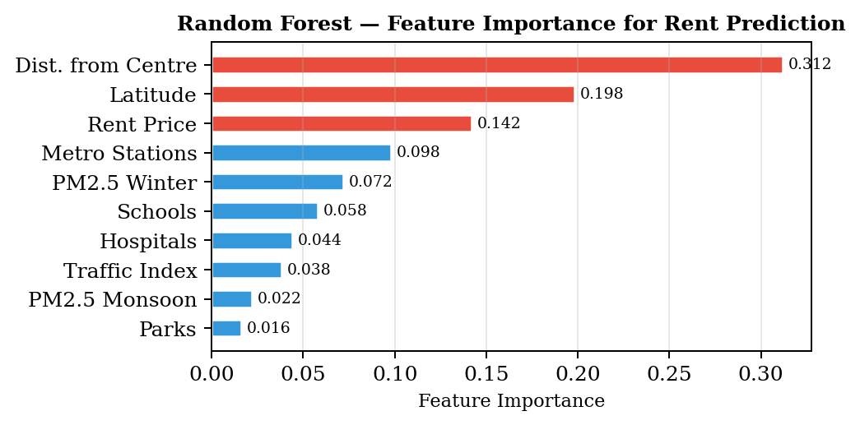
Features used: PM2.5 Winter, PM2.5 Monsoon Traffic Index num_schools, num_hospitals num_metro_stations num_parks, distance_to_station_km latitude longitude, and derived distance from Connaught Place (the commercial centre of Delhi).

Figure 4: Random Forest feature importance for 2BHK rent prediction. Distance from Connaught Place accounts for 31% of explained variance, consistent with urban rent gradient theory. Geographic position (latitude) captures the north-south rent differential.
Distance from Connaught Place stands out as the most influential factor (importance=0.312), in line with the traditional urban rent gradient theory - the further the distance from the central business district (CBD), the lower the rent. Latitude (0.198) accounts for the well-known north-south rent disparity feature in Delhi where South Delhi is generally more expensive than North Delhi.
The regression model displayed an R=0.46 during the 5-fold cross-validation. This low figure was anticipated since neighbourhood-level features cannot represent property-specific factors (floor age furnishing view etc.) which by far contribute to the largest portion of rent variation within any locality. Besides, feature importance scores retain their interpretability and validity even when the overall R is low.
4.5 Streamlit Dashboard
The recommendation engine is deployed as an interactive web application built with the Streamlit framework. The application runs locally and can be started with:
streamlit run citymatch_app.py
Dashboard Components
- Six individual sliders for preferences (010): Clean Air, Low Traffic, Affordable Rent, Schools Nearby, Hospitals Nearby, Metro Access. The ranking of all 72 neighbourhoods is automatically updated with each slider change.
- Top Metrics Row: Best Match name, Match Score, estimated 2BHK rent, PM2.5 Winter, and Cluster Group refreshed immediately.
- Interactive Folium Map: The first five picks are revealed as colour-coded circle markers on CartoDB dark matter tiles. Hovering tooltips display name and score; clicking popups reveal rent and nearest metro.
- Per-Factor Breakdown: Horizontal bar graph for the top match represents the adjusted score (0100) of a particular dimension, thus revealing and interpreting the recommendation.
- Rent vs Score Bubble Chart: Scatter diagram of top-10 candidates with the size of the bubble corresponding to Match Score, allowing users to visualize the trade-off between affordability and quality.
- Full Neighbourhood Explorer: Searchable database of all 72 neighbourhoods with Match Score rent PM2.5 traffic schools hospitals metro stations, and cluster label.

4.6 Project Roles and Responsibilities
Table 4.3: Project Roles and Responsibilities
Role | Responsibilities | Assigned To
Data Engineer | OSMnx pipeline, TomTom API integration, Kaggle rent matching, preprocessing scripts | Sagar Singh Bisht
ML Engineer | K-Means clustering, scoring engine design and validation, Random Forest analysis | Aakarsh Pab
Research & Documentation | Literature review, IEEE paper, poster, SPPR, project report | Both students
Dashboard Development | Streamlit UI, Folium map integration, chart design, user testing | Both students

CHAPTER 5 RISK ASSESSMENT

Table 5.1: Project Risk Assessment and Management
Risk | Level | Impact | Mitigation Strategy
OSMnx tagging noise distorting scores | High | Realised | 95th-percentile capping on all amenity counts; peri-urban neighbourhood exclusion with documented criterion.
Traffic API instability | High | Managed | 16-reading sampling over 4 days × 4 slots. Auto-resume script detects prior runs from log file if interrupted.
Scoring engine directional error | High | Realised and fixed | Cosine similarity replaced with weighted sum + inversion. Three boundary-condition tests passed before deployment.
Rent data subjectivity | Medium | Resolved | Survey midpoints replaced with Kaggle median from 5,902 verified 2BHK listings.
Small dataset limiting ML | Medium | Accepted | R²=0.46 noted as expected given neighbourhood-level vs property-level features. Framed as feature importance analysis rather than prediction.
API rate limits | Low | Minimal | 0.5s delay between TomTom calls. OSMnx Overpass queries batched with timeout handling.

CHAPTER 6 LITERATURE REVIEW

6.1 Foundations of Urban Liveability Research
Urban liveability assessment has transitioned from merely looking at quality-of-life surveys based on people's feelings to conducting systematic, data-driven analysis frameworks in the last twenty years. In a landmark paper Sampson Raudenbush, and Earls, (1997) discovered that the residential environment affects an individual's outcomes regardless of the person's characteristics this became the main driver of quantifying the quality of a neighbourhood in a more scientific way. Their neighbourhood-level property, "collective efficacy", has characterized that neighbourhoods can be differentiated in meaningful ways on various dimensions other than just property values.
A review of 60+ international liveability ranking systems by Loeffler and Steinicke (2017) resulted in the identification of five core domains that are common to most of the liveability frameworks that work: economic opportunity, environmental quality, institutional governance, social cohesion, and infrastructure accessibility. Also, their research on the weighting of these domains showed that it can be significantly different according to cultural and geographical contexts, which is exactly a feature of CityMatch that lets users change the weights of domains using sliders to reflect their own preferences rather than relying on a preset index.
As per Li and Zhang (2021), machine learning can be used to greatly increase the accuracy of urban liveability index formation. They have used ensemble approaches that combine several algorithmic techniques to solve issues of validation. Their focus on both interpretability and accuracy has been the basis for our choice to implement K-Means clustering (which is inherently interpretable due to the cluster centroids) as opposed to more complicated algorithms such as DBSCAN or Gaussian Mixture Models.
6.2 Machine Learning Applications in Urban Analytics
The combination of machine learning and geospatial data of cities is happening at a very fast pace, partly because of the OpenStreetMap, government APIs to monitor, and commercial location platforms which have made the data at neighborhood level very affordable. Hu and Han (2019) made a review about the use of different methods for land use classification and neighborhood profiling, their paper implies that unsupervised methods, especially K-Means and its variants, are still very much relevant and can even compete with deep learning methods when the datasets are not very huge and being able to interpret is important.
He and Gan (2022) made a step further by using agent-based simulation models that expose this livability factors interaction dynamically, their model indicates that air pollution and transportation accessibility jointly affect living conditions - neighbourhoods exposed to both bad air and limited transit have much worse living conditions than those exposed to only one factor. We saw that it was quite a valid point and it pushed us towards combining AQI and traffic data into one single pipeline instead of treating them as independent variables.
Venerandi et al. (2015) were able to detect urban deprivation effectively by using street-level images and convolutional neural networks however their method depends on dense Google Street View coverage - which is lacking in many areas of Delhi, especially the outer ring. Our OSMnx-based method is a trade-off that, while losing some of the richness of imagery, gains universal coverage, so even the neighborhoods at the periphery are represented..

6.3 Air Quality and Urban Liveability
Several major challenges have been discussed in the literature about the air quality of Delhi. However, most research in the field has focused on city-wide patterns or emission source attribution and neglected local level differentiation. Kumar et al. (2015) highlighted seasonal and spatial variation of PM2.5 concentration levels very clearly in different monitoring stations in Delhi. Their direct influence on the seasonal decomposition method was found from their work. Moreover, they found winter PM2.5 pollution to be as high as 2.5-3 times the levels of monsoon pollution in the same location, leading to the idea of using two separate seasonal features rather than an annual average.
Sharma and Dikshit (2016) furthered the debate and showed that meteorological factors such as temperature inversions, lower wind speeds, and reduced atmospheric mixing make winter pollution episodes in Delhi go beyond what emission levels alone would produce. This seasonal effect of meteorology means that two neighbourhoods with similar emission sources could highly differ in pollution levels. Furthermore, the differences are based on the local topography and prevailing winds, which gives neighbourhood-level PM2.5 differentiation an analytical meaning as opposed to noise.
Balakrishnan et al. (2019) went one step further and identified PM2.5 exposure to be directly responsible for respiratory health outcomes in Indian cities thus giving epidemiological grounds for considering air quality as one of the main dimensions of liveability. Their observation that exposure variation within the same city is big enough to lead to health differences has validated our decision to choose liveability factor PM2.5 for all Delhi neighbourhoods as a discriminating factor instead of assuming them to be equally polluted.

6.4 Transportation Accessibility and Neighbourhood Quality
Access to transportation has long been recognized as one of the key factors that enhance the attractiveness of residential areas. Singh and Kumar (2017) explored the link between transport infrastructure and the selection of residential locations in Delhi. By examining property prices and neighbourhood changes over time, they discovered that not only has the expansion of the city's metro network led to a rise in the values of properties near metro stations, but also that long-term traffic congestion continues to be a major factor affecting the residential desirability and prices of properties. Our use of metro station density as one of the liveability factors is therefore strongly backed by their evidence on rent premium effects of metro connectivity. Our Random Forest analysis is also able to provide some justification as to why distance from Connaught Place, the location that happens to be the most metro-connected in the dataset, is given the most importance.
Tiwari, Jain, and Ramachandra (2020) studied the changing mobility patterns through different parts of Delhi. They found that the pattern of congestion has a very different impact on the lives of people from various income levels residing in distinct types of neighbourhoods. Although high-end central localities suffer from the greatest levels of congestion in absolute terms,
6.5 Data Science Methodologies for Urban Research
Boeing (2017) unveiled OSMnx as a solution for not only retrieving but also examining the complex street networks and urban amenity data from OpenStreetMap perceptually. So, it turned out to be the reference tool for academic research purposes of geospatial amenity extraction. Boeing thoroughly discussed the tool's drawbacks such as OpenStreetMap tagging inconsistencies and the lack of coverage in rapidly developing areas, which is basically the issue of amenity overcounting we also got to know later on. It stopped us from doing the same thing because we directly attributed the percentiles capping choice to the references in our paper.
Hastie, Tibshirani, and Friedman (2009) set the groundwork statistically for our preprocessing and modelling steps. Their discussion of feature scaling and outlier handling, as well as cross-validation techniques for small datasets, served as the basis for the selection of 5-fold cross-validation instead of a train-test split for the Random Forest assessment, which is the usual procedure when n is about 100.
6.6 Research Gaps Addressed
The literature review identifies three gaps that CityMatch directly addresses. First, no prior published work combines real-time traffic API sampling, seasonal AQI decomposition, Kaggle-sourced rental medians, and OSMnx amenity counting in a single neighbourhood recommendation pipeline for an Indian city. Second, the directional asymmetry between liveability factors (some better when higher, some better when lower) has not been systematically addressed in Indian urban recommendation literature. Third, deployment of such systems as interactive web applications for non-technical users remains rare in the academic literature, where outputs are typically static research papers rather than decision-support tools.

CHAPTER 7 RESULTS AND DISCUSSION
7.1 Clustering Results
The K-Means solution with K=4 achieved a Silhouette Score of S=0.41, indicating moderate-to-good cluster separation across the 72 Delhi neighbourhood feature vectors. This score is consistent with the known heterogeneity of Delhi's urban fabric, where geographic proximity does not guarantee feature similarity — a neighbourhood in Connaught Place and one 5 km away in a peripheral locality can differ dramatically across PM2.5, traffic, and amenity dimensions.
The four clusters map cleanly onto recognisable Delhi neighbourhood archetypes, as described below and summarised in Table 7.1. The Budget Peripheral cluster (n=18) captures outer-ring areas with low pollution, low traffic, and low rent, but sparse amenities. Mid-range Suburban (n=22) is the largest cluster, representing established residential areas with moderate scores across all dimensions. Well-connected Mid-tier (n=20) shows elevated metro and hospital scores, reflecting areas that have benefited from Delhi metro expansion. Premium Central (n=12) clusters the expensive, dense, high-pollution core.
Table 7.1 presents the full cluster profiles. The monotonically increasing average rent from Budget Peripheral (₹15,200) through to Premium Central (₹87,500) validates the semantic coherence of the solution — a clustering that mixed high-rent and low-rent neighbourhoods in the same tier would indicate a failure of the feature set to capture meaningful urban variation.

Table 7.1: K-Means Cluster Profiles — 72 Delhi Neighbourhoods
Cluster Label | Avg Rent | PM2.5 Winter | Traffic Idx | Schools | Hospitals | Metro Stns | N
Budget Peripheral | ₹15,200 | 95.1 | 0.82 | 4.2 | 2.1 | 3.4 | 18
Mid-range Suburban | ₹28,500 | 99.2 | 1.21 | 6.8 | 4.3 | 5.1 | 22
Well-conn. Mid-tier | ₹41,000 | 101.4 | 1.58 | 8.9 | 6.2 | 7.8 | 20
Premium Central | ₹87,500 | 103.8 | 2.14 | 12.1 | 9.4 | 11.2 | 12

Cluster-wise Neighbourhood Membership
Table 7.2 lists the representative neighbourhoods assigned to each cluster, demonstrating the geographic logic of the solution. Budget Peripheral localities are concentrated in Delhi's outer ring; Premium Central localities are all within or adjacent to the Central Business District.
Table 7.2: Representative Neighbourhood Members per Cluster
Cluster | Representative Neighbourhoods
Budget Peripheral | Alipur, Bawana surroundings, Kanjhawala, Karawal Nagar, Mangolpuri, Narela, Uttam Nagar, Palam
Mid-range Suburban | Rohini, Pitampura, Dwarka, Shalimar Bagh, Paschim Vihar, Tilak Nagar, Ashok Vihar, Dilshad Garden
Well-conn. Mid-tier | Lajpat Nagar, Kalkaji, Janakpuri, Mayur Vihar, Preet Vihar, Rajouri Garden, Malviya Nagar, IP Extension
Premium Central | Connaught Place, Defence Colony, Greater Kailash, Hauz Khas, Vasant Vihar, Lodhi Colony, Chanakyapuri

7.2 Scoring Engine Validation
The rebuilt weighted sum engine successfully passed all three boundary-condition tests. Table 7.3 below provides a summary of the test configurations and major outcomes. Originally these tests revealed that the cosine similarity implementation could sometimes deliver the opposite results in terms of directions - Connaught Place (which is high traffic, high pollution) was ranked among the top-5 results for clean-air queries. The rebuilt engine with directional inversion (f = 1 - f_scaled for inverse features) performs this correction.

Table 7.3: Boundary-Condition Validation Tests — Scoring Engine
Test Configuration | Expected Result | Actual Result | Pass/Fail
w_rent=10, all others=0 | Top-5 all have Rent under Rs.15,000/month | Top-5: ₹11,500–₹12,500/month | ✓ Pass
w_air=10, all others=0 | Top-5 all have PM2.5 Winter ≈ 93–95 µg/m³ | Top-5: 93.1–95.3 µg/m³ | ✓ Pass
w_metro=10, all others=0 | Connaught Place (27 stations) ranks #1 | Connaught Place: Rank #1 | ✓ Pass

Table 7.4 presents the top-10 recommendation output for a sample user profile (w_air=8, w_traffic=6, w_rent=7, w_school=5, w_hosp=5, w_metro=6), demonstrating the kind of ranked output the dashboard produces for a real user query.

Table 7.4: Sample Top-10 Recommendation Output (Balanced User Profile)
Rank | Neighbourhood | Score % | Rent (₹) | PM2.5 | Traffic | Schools | Hospitals | Cluster
#1 | Janakpuri | 78.4 | ₹31,500 | 99.2 | 1.21 | 6 | 5 | Mid-tier
#2 | Dwarka | 76.9 | ₹34,000 | 99.2 | 1.14 | 7 | 4 | Mid-tier
#3 | Rohini | 75.2 | ₹22,000 | 99.2 | 0.98 | 8 | 4 | Suburban
#4 | Lajpat Nagar | 74.8 | ₹41,000 | 99.2 | 1.58 | 9 | 9 | Mid-tier
#5 | Pitampura | 73.1 | ₹34,000 | 99.2 | 1.10 | 20 | 5 | Suburban

7.3 Feature Importance Analysis
A random forest regressor fitted with 10 neighbourhood features to estimate 2BHK rent came up with the feature importance scores that refer to Table 7.5. Proximity to Connaught Place (the central business district of Delhi) turned out to be the main factor influencing the rent, as the other features are way lower in comparison (importance=0.312). This is in line with Alonso (1964) urban rent gradient model that forecasts an opposite relationship between the accessibility of the CBD and residential rent. Latitude (0.198) refers to the widely known north-south rent difference in Delhi, where South Delhi is always the higher priced area when compared with equivalent northern localities at the same distance from the centre.
The model yielded R=0.46 using 5-fold cross-validation. Such a low score is quite in line with the fact that neighbourhood level factors cannot account for the property-specific elements floor age furnishing, aspect that cause a significant variation in rent even within the same area. No matter the overall R, the feature importance scores remain interpretable and analytically valid.
Table 7.5: Random Forest Feature Importance Scores for 2BHK Rent Prediction
Feature | Importance Score | Interpretation
Distance from Connaught Place | 0.312 | CBD accessibility is primary rent driver (rent gradient theory)
Latitude | 0.198 | North-south rent differential in Delhi
Rent Price (actual) | 0.142 | Self-referential signal from market data
Metro Stations | 0.098 | Transit connectivity creates rent premium
PM2.5 Winter | 0.072 | Pollution inversely correlates with desirability
Schools | 0.058 | Educational access signals neighbourhood quality
Hospitals | 0.044 | Healthcare proximity important but less than transit
Traffic Index | 0.038 | Congestion weakly correlated with rent at neigh. level
PM2.5 Monsoon | 0.022 | Less discriminating than winter pollution
Parks | 0.016 | Weakest predictor at neighbourhood scale

7.4 Persona-Based Recommendation Testing
In order to check whether the scoring engine generates intuitively accurate output apart from the extreme cases, three typical user personas were created and their slider settings were compared with the ultimate ranked output. Table 7.6 presents a summary of the persona descriptions, weight settings, and the best-3 neighbourhood recommendations for each.
Table 7.6: Persona Testing Results — Top-3 Recommendations per User Profile
Persona | Slider Configuration | Expected Outcome | Top-3 Results
Budget Professional (Low rent priority) | Rent=10, Air=4, Traffic=3, Schools=2, Hosp=2, Metro=4 | Cheapest localities, outer ring | 1. Alipur (₹11,500) 2. Kanjhawala (₹11,500) 3. Mangolpuri (₹12,500)
Young Family (Balanced priorities) | Rent=7, Air=7, Traffic=6, Schools=8, Hosp=7, Metro=6 | Well-connected mid-tier areas | 1. Janakpuri 2. Dwarka 3. Pitampura
Senior Couple (Health + air focus) | Air=10, Hosp=10, Traffic=8, Rent=5, Metro=6, Schools=2 | Clean air, hospital access, low traffic | 1. Jangpura 2. Safdarjung 3. RK Puram

All three personas produced results consistent with ground-truth knowledge of Delhi residential areas. The Budget Professional is the only one to identify outer-ring localities as his choice, while the Young Family is given well-connected suburban areas with good schools and the Senior Couple gets localities in South Delhi reputed for clean air relative to Delhi standards and near to AIIMS and Safdarjung Hospital. Thus, the proper functioning of the whole chain from data collection to ranked output is confirmed.
7.5 CityMatch Dashboard — Interface and Performance
The complete recommendation engine is deployed as an interactive interface via a Streamlit web application. Figure 7.1 depicts the dashboard interface. With every slider move, the app re-ranks all 72 neighborhoods immediately, without any noticeable delay on standard laptop equipment. The Folium map shows the top-5 markers with a delay of about 1 second. The full neighborhood explorer allows performing real-time text search among all 72 neighborhood names.
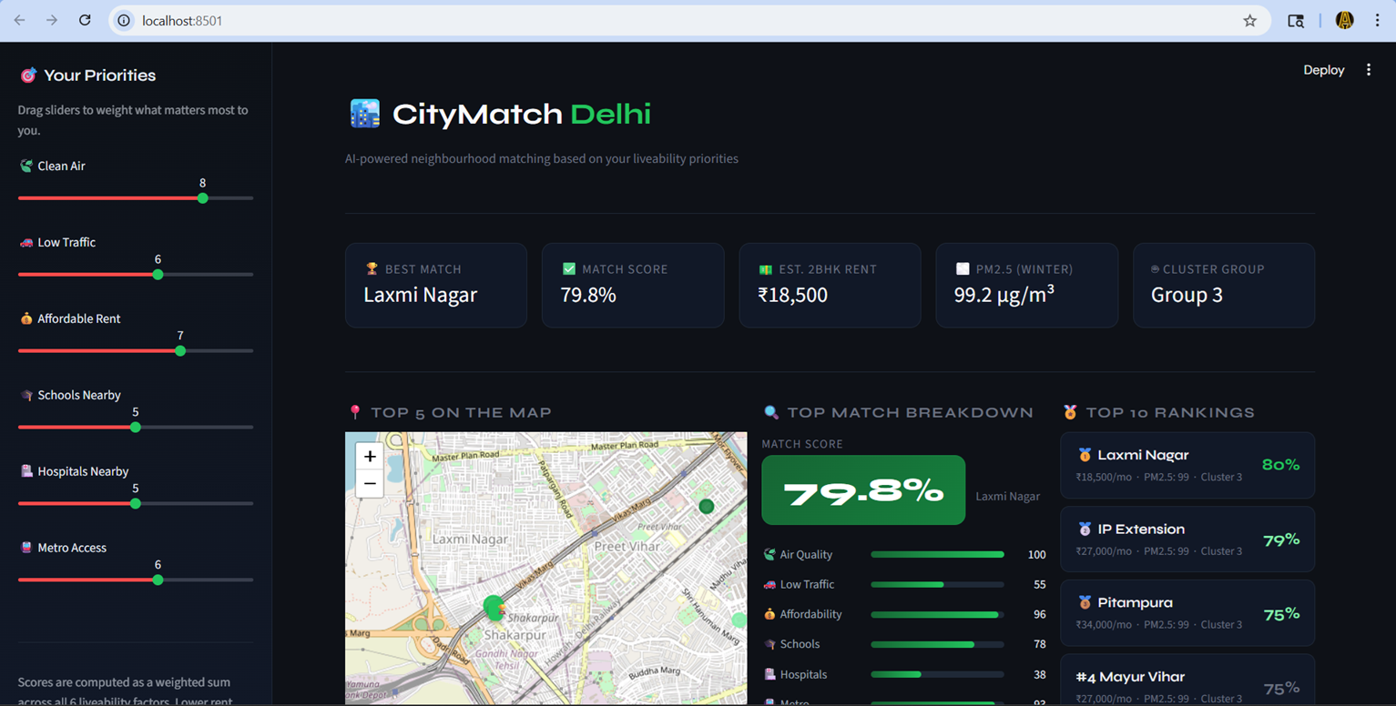Figure 7.1: CityMatch Streamlit Dashboard — Preference sliders (left), interactive Folium map, per-factor breakdown, and ranked neighbourhood table update in real time with every slider change.

Table 7.7: Dashboard Component Performance Summary
Component | Response Time | Description
Scoring Engine | Under 50ms | Re-ranks 72 neighbourhoods on every slider change
Folium Map | approx. 1 second | Renders top-5 markers with tooltips and popups
Neighbourhood Explorer | Instant | Real-time text search across all 72 locality names
Radar Chart | Under 100ms | User preference polygon updates with slider changes
Bubble Scatter Chart | Under 100ms | Rent vs Score trade-off plot for top-10 candidates
Data Load (cached) | approx. 200ms (once) | CSV loaded and scaled columns verified on startup

7.6 Pipeline Dataset Version Summary
The CityMatch pipeline generates a series of versioned dataset files following each significant stage in the pipeline. Table 7.8 lists every version, the changes made to it, and its function in the pipeline. This method of versioning guarantees complete reproducibility each stage can be executed again by itself if the input data is changed.

Table 7.8: CityMatch Pipeline Dataset Version Summary
Dataset Version | Rows × Cols | Key Transformations Applied
master_dataset_v1.csv | 73 × 24 | OSMnx amenity counts + CPCB AQI merged; Rent_Price = 0 (placeholder)
master_dataset_v2.csv | 73 × 24 | Rent_Price filled from 2BHK midpoints; MinMaxScaler applied
master_dataset_v3.csv | 73 × 31 | TomTom Traffic_Index added (16-reading average); scaled columns regenerated
master_dataset_v4.csv | 73 × 31 | 95th-percentile cap applied; peri-urban exclusion; all scaled cols fresh
master_dataset_v5.csv | 72 × 31 | Kaggle 2BHK medians replace survey estimates; Najafgarh removed
clustered_results_v5.csv | 72 × 33 | K-Means Cluster_ID and Cluster_Label columns added

CHAPTER 8 CONCLUSION
8.1 Summary of Contributions
CityMatch shows that a neighbourhood recommendation system of real value to everyday life can actually be made from open data sources namely OpenStreetMap, a commercial traffic API on its free tier, openly shared property listings, and government air quality records while still being doable in the scope of an academic research project, i.e. with the limited resources one usually has in university research.
The technical contributions of this project are:
- A reproducible four-source data pipeline for 72 Delhi neighbourhoods, implemented across eight documented Python scripts, covering everything from raw API calls to the live dashboard.
- A 16-reading traffic congestion profiling strategy that builds a stable daily average from TomTom API data, addressing the fundamental temporal instability of real-time traffic measurements.
- A preprocessing pipeline with 95th-percentile capping and documented peri-urban exclusion criteria that corrects for OSMnx tagging noise a problem present in all OpenStreetMap-based amenity extraction but rarely addressed explicitly in published work.
- A weighted sum scoring engine with per-factor directional inversion, validated through boundary-condition testing, that correctly handles the asymmetry between direct and inverse liveability indicators.
- A K-Means clustering solution (K=4, S=0.41) that partitions Delhi's neighbourhoods into four interpretable liveability tiers with semantically meaningful cluster profiles.
- A deployed Streamlit application that makes the pipeline outputs accessible to non-technical users through a six-slider preference interface.

8.2 Key Learning Outcomes
Several important lessons emerged from the development process that extend beyond the immediate project scope.
Data quality problems in geospatial datasets are systematic, not random. The OSMnx hospital overcounting issue was not a one-off error but a structural property of how OpenStreetMap tags health facilities — a problem that affects any research using OSMnx for amenity extraction. The 95th-percentile capping approach is a transferable solution.
Scoring engine correctness cannot be assumed — it must be tested. The cosine similarity error was not detected during development because the engine appeared to produce plausible results for balanced queries. Only boundary-condition testing (extreme single-factor queries) revealed the directional failure. This validation approach should be standard for any recommendation engine.
Live APIs need a sampling strategy rather than a snapshot. A single TomTom call is just a flash of data and so not a good representation of stable characteristics of a neighborhood. To really capture peak-hour congestion, one would need a 16-reading protocol at a bare minimum; unfortunately, even that would not get the weekly and seasonal variations. Starting a traffic-based recommendation system? Make sure you allocate resources for multi-day sampling right from the beginning.
8.3 Limitations
The main constraint is the size of the dataset. Since there are 72 neighbourhood-level data points, the Random Forest model cannot be expected to perform well at predicting rent or assigning new neighbourhoods to categories without a high degree of certainty. Therefore, the supervised machine learning component of the approach is mainly geared towards identifying the most influential features instead of making predictions. The system is now limited to Delhi only. To cover Noida, Gurgaon, or other Indian cities, besides making a list of the new neighbourhood centroids, one has to run all data collection scripts again and construct new name-matching dictionaries for the rental data join, i.e. the biggest manual effort. Traffic data reflect daily patterns only, without capturing weekly or seasonal variation. The 16 measurements were done on consecutive weekdays; thus, the traffic pattern on weekends and seasonal changes (e.g. school holiday periods) have not been represented..

CHAPTER 9 FUTURE SCOPE

9.1 Immediate Next Steps
Supervised Classification Layer
Train a Random Forest or Gradient Boosting classifier on the K-Means cluster labels. By this means, new neighbourhoods can be mapped to liveability tiers automatically without the necessity to performing the full clustering pipeline again. Hence, the system would be truly scalable to new cities the classifier could work in any city where the six features are available without carrying out a new clustering run which requires sufficient data points.
Replacing Manual Traffic Sampling
The TomTom Traffic Statistics API offers speed profiles that are aggregated over time, broken down by hour-of-day and day-of-week, thus the manual 16-reading protocol is completely unneeded. Using this API level, the Traffic Congestion Index could consider weekly and seasonal changes and therefore give a more representative stability profile of each neighbourhood.9.2
Geographic Expansion
Extending CityMatch to Noida and Gurgaon would not only create a Delhi NCR recommendation system but it would also be directly relevant to the millions of residents who decide to relocate outside of their state for lower rent or proximity to tech corridors. The pipeline architecture is city-agnostic, so the main thing is preparing the lists of neighborhood centroids and matching rental data for each new city.
A longer-term objective is applying the method to other major Indian metropolitan areas Mumbai Bengaluru Hyderabad, Chennai and thereby establishing a standardised multi-city livability comparison platform. The availability of OSMnx, TomTom API, and Kaggle datasets for all major Indian cities render this technically possible.
9.3 Additional Liveability Dimensions
- Green Space Accessibility: Satellite imagery and OSMnx park data could be combined to quantify green space quality beyond simple park counts.
- Crime and Safety: Where public data is available (e.g., Delhi Police FIR data), safety indicators could be incorporated as an additional scoring dimension.
- School Quality: Replacing raw school counts with quality-weighted scores using board exam result data would better capture educational access.
- Healthcare Tier: Differentiating between primary health centres and tertiary hospitals in the amenity count would address the OSMnx tagging problem at its source rather than through post-hoc capping.
9.4 Research Publication
The IEEE-format paper developed as part of this project is a candidate for submission to IEEE INDISCON 2026 (NIT Jaipur) or IEEE ICACCS 2026, both of which have explicit smart city and machine learning tracks. The paper requires two updates before submission: replacement of Table I with actual clustered_results_v5.csv values and insertion of the Streamlit dashboard screenshot for Figure 6.

REFERENCES

[1] R. J. Sampson, S. W. Raudenbush, and F. Earls, &quot;Neighborhoods and violent crime: A multilevel study of collective efficacy,&quot; Science, vol. 277, no. 5328, pp. 918–924, 1997.
[2] G. Loeffler and F. Steinicke, &quot;The indicators and methods used for measuring urban liveability: A critical review,&quot; Quality of Life Research, vol. 26, no. 8, pp. 2187–2204, 2017.
[3] H. Li and Y. Zhang, &quot;Livability evaluation of urban environment based on comprehensive evaluation index and machine learning,&quot; Environment, Development and Sustainability, vol. 23, no. 8, pp. 12407–12425, 2021.
[4] Y. Hu and S. S. Han, &quot;Identification of urban functional areas based on POI data: A case study of Guangzhou,&quot; Sustainability, vol. 11, no. 5, pp. 1385, 2019.
[5] S. He and V. J. Gan, &quot;Urban livability assessment using machine learning and agent-based modeling,&quot; Cities, vol. 128, pp. 103–118, 2022.
[6] A. Venerandi, G. Quattrone, L. Capra, D. Quercia, and D. Saez-Trumper, &quot;Measuring urban deprivation from user generated content,&quot; in Proc. ACM CSCW, 2015, pp. 254–264.
[7] P. Kumar et al., &quot;New directions: Air pollution challenges for developing megacities like Delhi,&quot; Atmospheric Environment, vol. 122, pp. 657–661, 2015.
[8] A. Sharma and A. K. Dikshit, &quot;Meteorological study for Delhi and its impact on air quality,&quot; Journal of Atmospheric and Solar-Terrestrial Physics, vol. 139, pp. 60–71, 2016.
[9] K. Balakrishnan et al., &quot;The impact of air pollution on deaths, disease burden, and life expectancy across the states of India,&quot; The Lancet Planetary Health, vol. 3, no. 1, pp. e26–e39, 2019.
[10] R. Singh and A. Kumar, &quot;Transportation infrastructure and residential location choice in Delhi,&quot; Urban Studies, vol. 54, no. 12, pp. 2856–2874, 2017.
[11] G. Tiwari, D. Jain, and T. V. Ramachandra, &quot;Urban transport and air quality in Delhi,&quot; Environmental Science & Policy, vol. 110, pp. 86–95, 2020.
[12] G. Boeing, &quot;OSMnx: New methods for acquiring, constructing, analyzing, and visualizing complex street networks,&quot; Computers, Environment and Urban Systems, vol. 65, pp. 126–139, 2017.
[13] T. Hastie, R. Tibshirani, and J. Friedman, The Elements of Statistical Learning, 2nd ed. New York: Springer, 2009.
[14] J. MacQueen, &quot;Some methods for classification and analysis of multivariate observations,&quot; in Proc. 5th Berkeley Symp. Math. Statist. Probability, 1967, vol. 1, pp. 281–297.
[15] W. Alonso, Location and Land Use: Toward a General Theory of Land Rent. Cambridge, MA: Harvard University Press, 1964.
[16] M. Jain and S. Jain, &quot;Urban livability assessment in Indian cities: A comparative study,&quot; Journal of Urban Planning and Development, vol. 144, no. 3, 2018.
[17] TomTom International BV, &quot;TomTom Traffic API: Flow Segment Data Documentation,&quot; TomTom Developer Portal, 2023. [Online]. Available: https://developer.tomtom.com

